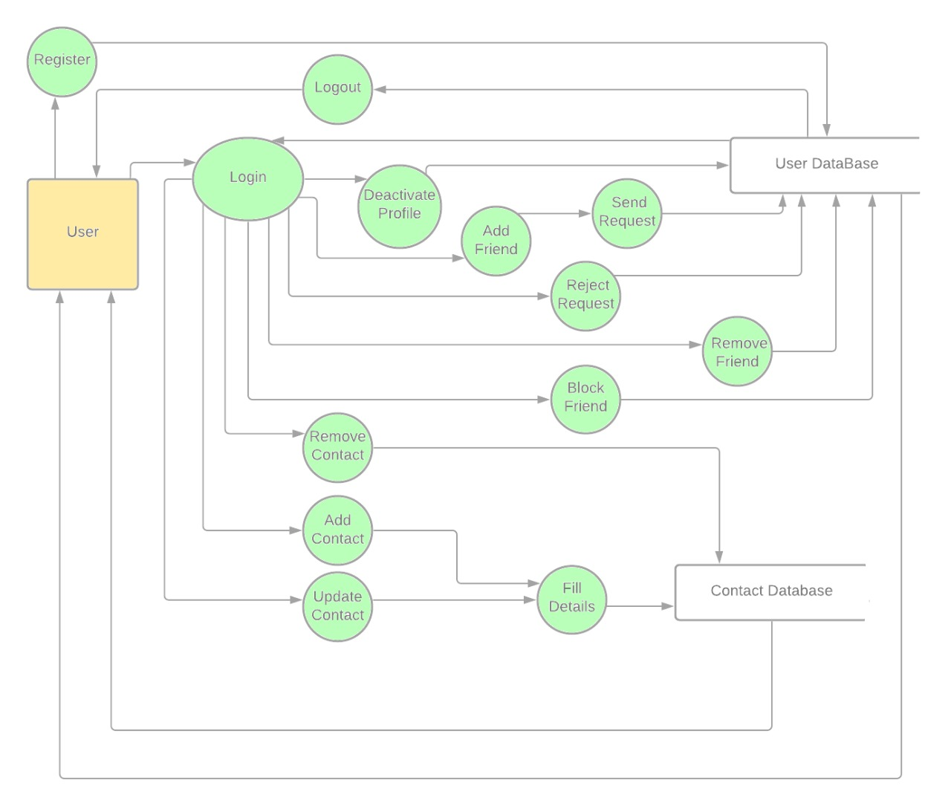

DFD LEVEL 1 (User)

